Press Release
Release from the morning of August 14, 2020.
APQA, Foreign Animal Disease Division, Director Hae-eun Gang (054-912-0857), Researcher Jin-joo Na
/ Provided on August 13 (three pages in total)
"Initiating" New Establishment of Korea's Only Laboratory Shielding Facility Against ASF

- Started designing laboratory base facility to support quarantine policy by developing ASF vaccine -
<Summary>
◈ APQA to start contracting design to establish shielding facility to test infection of African Swine Fever (ASF) in Korea
❍ Commencing construction next year, starting with design this July, to be completed in 2023 to complete a facility that will safely carry out experiments without the risk of external leakage of ASF virus
❍ Expected to actively support private-public cooperation of ASF in Korea and abroad to contribute to fastforward commercialization of ASF vaccine
Animal and Plant Quatantine Agency (commissioner, Bong-gyun Park, hereinafter 'APQA') commenced design contracting to establish the laboratory shielding facility* against infectious African Swine Fever (hereinafter 'ASF') last July.
* Shielding facility: Special enclosed (negative pressure) laboratory to safely perform infection experiment of live ASF virus without the risk of external leakage in a grade 3 biological laboratory (BL3)
In order to experiment infection of ASF virus in pigs by developing ASF vaccine, special facilities such as grade 3 biological laboratory is necessary, which had been absent in Korea.
❍ ASF is class 1 animal infectious disease with extremely high contagious and mortality rate. It first occurred in breeding pigs near the demilitarized zone (DMZ) last September and caused tremendous social and economic damage.
❍ In addition, infection cases are continuing in wild boars, and the extended occurrence of ASF in neighboring countries (China and Vietnam) means that there is constant risk of recurrence in domestic breeding pigs.
❍ Due to the lack of commercialized ASF vaccine worldwide, there is need to develop vaccines available to use in domestic quarantine sites, and to develop a dedicated ASF laboratory to conduct infection tests that are essential during vaccine development.
This new shielding facility will be the only dedicated laboratory for ASF in Korea, and will be built in the 4,381m2 area APQA site in Gimcheon over 4 years (2020 - 2023) at a budget of KRW 28.3.
❍ This facility consists of ASF virus infection laboratory (Animal BL3), laboratory for virus cultivation and infection experiment (BL3), and general laboratory (BL2).
❍ Design contracting started in July, and construction is to be completed in 2024.
❍ When this facility is completed, it is expected that various infection experiments will be conducted such as developing ASF vaccine, evaluation and selection in Korea.
Hae-eun Gang, the Director of Foreign Animal Disease Division of APQA said, "We will do our best to facilitate the project for establishing Korea's only ASF infection laboratory shielding facility, and plan to open the facility to private research institutes to fastforward commercialization of ASF vaccine."
Reference |  | Establishment of shielding laboratory for infection testing of African Swine Fever (ASF)

【Project Overview】
• Location: 177, Hyeoksin 8-ro, Gimcheon-si, Gyeongbuk (inside APQA site)
• Project Description: Establishment of shielding laboratory for advanced safety against infectious disease experiment to support ASF quarantine strategy
• Project Scale: 4,381㎡ (1 basement level, 3 ground levels)
• Project Budget: KRW 28,267 million (Budget item: livestock quarantine)
• Project Period: 4 years (design) 2020 - 2021 → (construction) 2021 - 2023 → (verification and licensing) 2023
□ Status and Issues
❍ The inflow of ASF in Korea (September 2019) caused tremendous damage to breeding pigs, and continued positive reports in wild boars are causing prolonged external risk factors to farms.
❍ Urgent need to vaccinate domestically separated ASF virus to pigs to analyze characteristics such as infection dynamics, set up effective quarantine strategy by shielding inflow of virus from boars to breeding pigs, and experiment infection to effectively set up quarantine strategy
❍ Due to lack of ASF preventive vaccines and cure worldwide, there is need for long-term quarantine strategy for the prolonged outbreak in Asian countries like China
□ Necessity
❍ Need to perform various ASF infection experiments to scientifically support establishment of effective national quarantine strategy against ASF
❍ Need to select and analyze ASF vaccines in prepartion for shifting toward ASF quarantine policy as future vaccination policy following constant risk in neighboring countries and the continued risk of inflow in Korea
❍ Need to urgently establish dedicated shielding laboratory for ASF to prevent leakage of ASF virus as basic infrastructure for ASF infection experiment
□ Project Implementation (Draft)
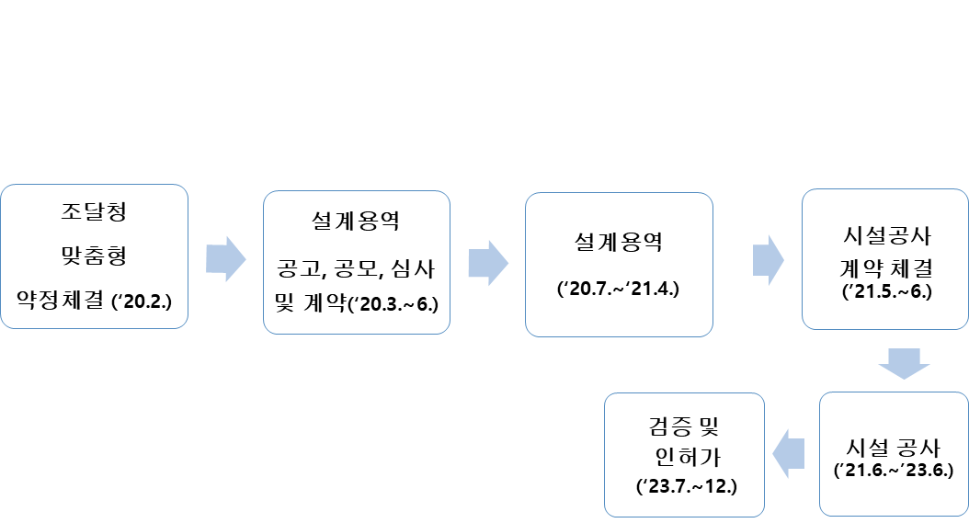
Customized agreement with Public Procurement Service (February 2020) | Announcement, public contest, examination and contract of design contracting (March - June 2020) | Design contracting  (July 2020 - April 2021) | Contract for facility construction (May - June 2021) | Facility construction (June 2021 - June 2023) | Verification and license (July - December 2023)

□ Expected Effect
❍ Newly established ASF shielding laboratory is expected to contribute to setting up mid- to long-term quarantine strategy to minimize ASF damage in Korea by conducting infection experiments such as evaluation of domestically occurring ASF pathogens and vaccine selection

