Press Release
Release from the morning of November 4, 2020.
Food Service Industry Division, Director Jae-sik Lee (044-201-2151), Deputy Director Hyun Lee (2155) / Provided on November 3 (four pages in total)
Let's Prepare Together for Listing of Korean Jang Culture in UNESCO!

International academic forum of comparison of fermented soybean paste in Korea, China and Japan, held online on November 12 (Thur)
<Summary>
◈ Overview of Northeast Asian International Academic Forum for Soybean Paste Culture
❍ Purpose: To promote the values and interests in Jang culture to list Korea's 'Jang culture' in the UNESCO Masterpieces of Oral and Intangible Heritage of Humanity in 2024
❍ Theme: "The value of soybean paste culture in Northeast Asia and listing of Korea's Jang culture in UNESCO Masterpieces of Oral and Intangible Heritage of Humanity"
❍ Date & Time: November 12, (Thur), 14:00-17:30, Korean Food Promotion Institute YouTube
❍ Pre-registration: Submit online at Hansik Portal (www.hansik.or.kr) by November 6 (Fri)
※ This year, to join 'social distancing' to prevent the spread of COVID-19, the event will be held as an online (untact) forum.
The Ministry of Agriculture, Food and Rural Affairs (Minister Hyun-soo Kim, hereinafter 'MAFRA'), together with the Korean Food Promotion Institute (president Yong-ja Lee), will be holding the '2020 Northeast Asian International Academic Forum for Soybean Paste Culture' in an online manner at 2 p.m. on November 12 (Thursday).

This forum will be the second session of the three-year international forum of soybean paste culture (2019-2021), supported by the MAFRA as a step to promote the listing of Korea's Jang culture in the UNESCO Masterpieces of Oral and Intangible Heritage of Humanity.
❍ Following the discussion on "Korea and ASEAN fermented food culture" in the first session, this year’s second forum will be held under the theme of "The Value of Northeast Asian Soybean Paste Culture and Listing of Korea’s Jang Culture in UNESCO Masterpieces of Oral and Intangible Heritage of Humanity."
❍ Experts in each field will share information and knowledge on the soybean paste culture of the three Northeast Asian countries (Korea, China, and Japan) and present the possibility and direction of the listing of the Jang culture in UNESCO Masterpieces of Oral and Intangible Heritage of Humanity.
When Jang culture is registered in UNESCO Masterpieces of Oral and Intangible Heritage of Humanity, it can be expected to have an economic effect as its international reputation and interest improve. As a food culture, 'Gimjang Culture' was registered in 2013.
Dongguk University Chairman Don-hee Lim, who has served as an international jury member for the UNESCO World Intangible Cultural Heritage Selection, leads the comprehensive discussion of the day.
❍ Keynote presentations include ▲ Emeritus Professor Han-hee Ham of Chonbuk National University, 'Research on Food Culture as Human Assets Designated by UNESCO' and ▲ Emeritus Professor Deok-in Yoon of Catholic Kwandong University, 'Value of Northeast Asian Soybean Paste Culture and Intangible Cultural Heritage Value of Korean Traditional Jang Culture'.
❍ This will be followed by the presentations on the culture of Korean, Chinese, and Japanese soybean pastes by ▲Professor Young-dong Bae of Andong University, 'the cultural tradition and meaning of the oldest Korean food doenjang', ▲ Emeritus Professor Deok-gyeong Choi of Pusan University, 'The emergence of Chinese soybean paste and the spread of soybean paste culture', ▲ Ogura Hiraku, fermentation Food researcher and designer, 'cultural anthropology of Japanese soybean fermentation'.

Vice Minister Jae-wook Lee of MAFRA said, "I hope this forum will contribute to the listing of Korean Jang culture in UNESCO Masterpieces of Oral and Intangible Heritage of Humanity in 2024 by proving the tradition and value of soybean paste culture in Northeast Asia and forming a consensus."
❍ "As it is conducted online to prevent the spread of COVID-19, I hope that it will be an opportunity for more people to participate and become interested in our Jang culture."
Anyone can access and watch this forum on the YouTube channel of the Korean Food Promotion Institute, and online pre-registration through the Hansik Portal will be held until November 6 (Fri), allowing you to post questions and participate in events (Onnuri gift certificate worth KRW 10,000 to 100 people).
Attachment 1 |  | Poster of the 2020 Northeast Asian International Academic Forum for Soybean Paste Culture

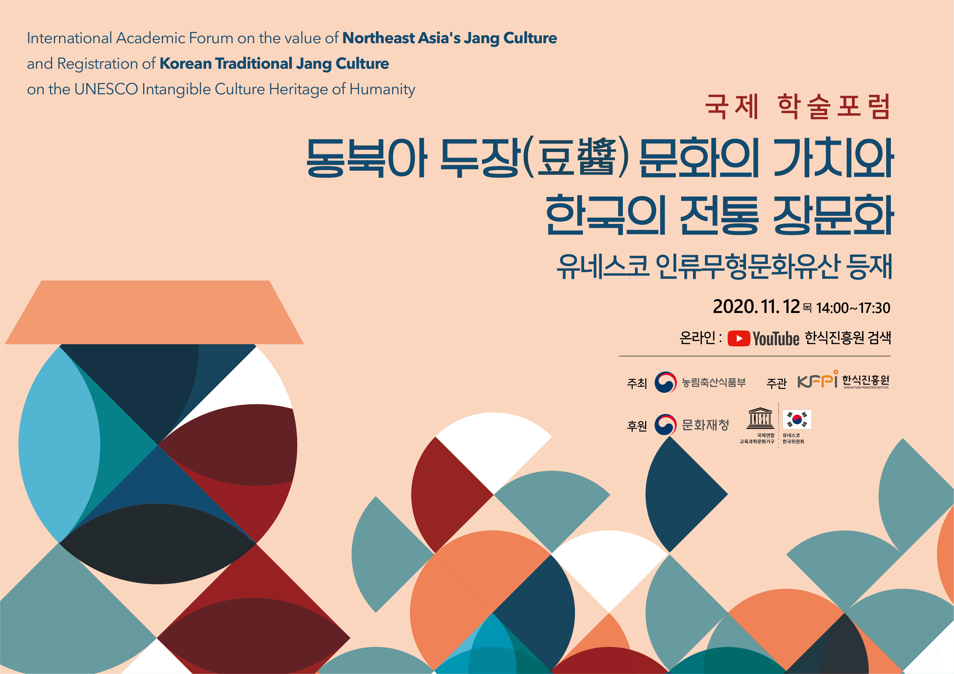

Attachment 2 |  | Overview of the 2020 Northeast Asian International Academic Forum for Soybean Paste Culture

□ Project Overview
ㅇ (Theme) The cultural heritage value of the soybean paste culture in Northeast Asia and the prospect of being registered as a UNESCO intangible cultural heritage
ㅇ (Host) Ministry of Agriculture, Food and Rural Affairs
ㅇ (Organizer) Korean Food Promotion Institute
ㅇ (Sponsors) Cultural Heritage Administration, Korean Committee for UNESCO
ㅇ (Date and place) November 12, 2020 (Thu) 14:00-17:30, Korean Food Promotion Institute YouTube (online)
□ Program Sequence
※ (Languages) Simultaneous interpretation for each language (Korean/Japanese) for each country of presentation
Time | Subject (draft) | Presenter (country)
14:00-14:05 (05 minutes) | Opening ceremony
14:05-14:10 (05 minutes) | Introduction of speaker
14:10-14:18 (08 minutes) | Opening address | Director of Promotion Institute
14:18-14:26 (08 minutes) | Welcoming address | Ministry of Agriculture, Food and Rural Affairs
14:26-14:30 (04 minutes) | Commemorative photo | Honored guests and speakers
14:30-15:00 (25 minutes) | (Keynote presentation 1) Research on food culture as a human asset designated by UNESCO | Emeritus Professor Han-hee Ham of Chonbuk National University
14:55-15:00 (5 minutes) | Q & A | Participants
15:00-15:25 (25 minutes) | (Keynote presentation 2) The value of soybean paste culture in Northeast Asia and intangible cultural heritage value of Korean traditional Jang culture | Emeritus Professor Deok-in Yoon of Catholic Kwandong University
15:25-15:30 (5 minutes) | Q & A | Participants
(15:30-15:50) Break time
15:50-16:10 (20 minutes) | (Topicp resentation 1) Cultural tradition and meaning of Doenjang (soybean paste), the oldest Korean food | Professor Young-dong Ahn of Andong University
16:10-16:15 (5 minutes) | Q & A | Participants
16:15-16:35 (20 minutes) | (Topic presentation 2) The advent of Chinese Doujiang (豆醬) and the spread of soybean paste culture | Emeritus Professor Deok-Gyeong Choi of Pusan National University
16:35-16:40 (5 minutes) | Q & A | Participants
16:40-17:00 (20 minutes) | (Topic presentation 3) Cultural anthropology of Japanese soybean fermentation | Hiraku Ogura, Fermented Food Researcher and Designer
17:00-17:05 (5 minutes) | Q & A | Participants
17:05-17:30 (25 minutes) | Presenters' (Korea, China, Japan) comprehensive discussion | (Moderator) Chair Professor Don-hee Lim of Dongguk University
17:30 | Closing ceremony

